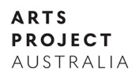
MEDIA RELEASE
13 May 2021

Arts Project Australia presents 4 x 4 Artist Solos
15 May – 27 June, 2021

Following the successful launch of its new gallery space at Collingwood Yards, Arts Project Australia is excited to bring together four solo shows comprising artists Monica Lazzari, Rebecca Scibilia, James MacSporran, and Samraing Chea in 4 x 4 Artist Solos. The artists each hold distinctive practices and collectively capture the essence of colour, imagination, narrative, and pattern, and speak on the energies of society and nuances of everyday life.

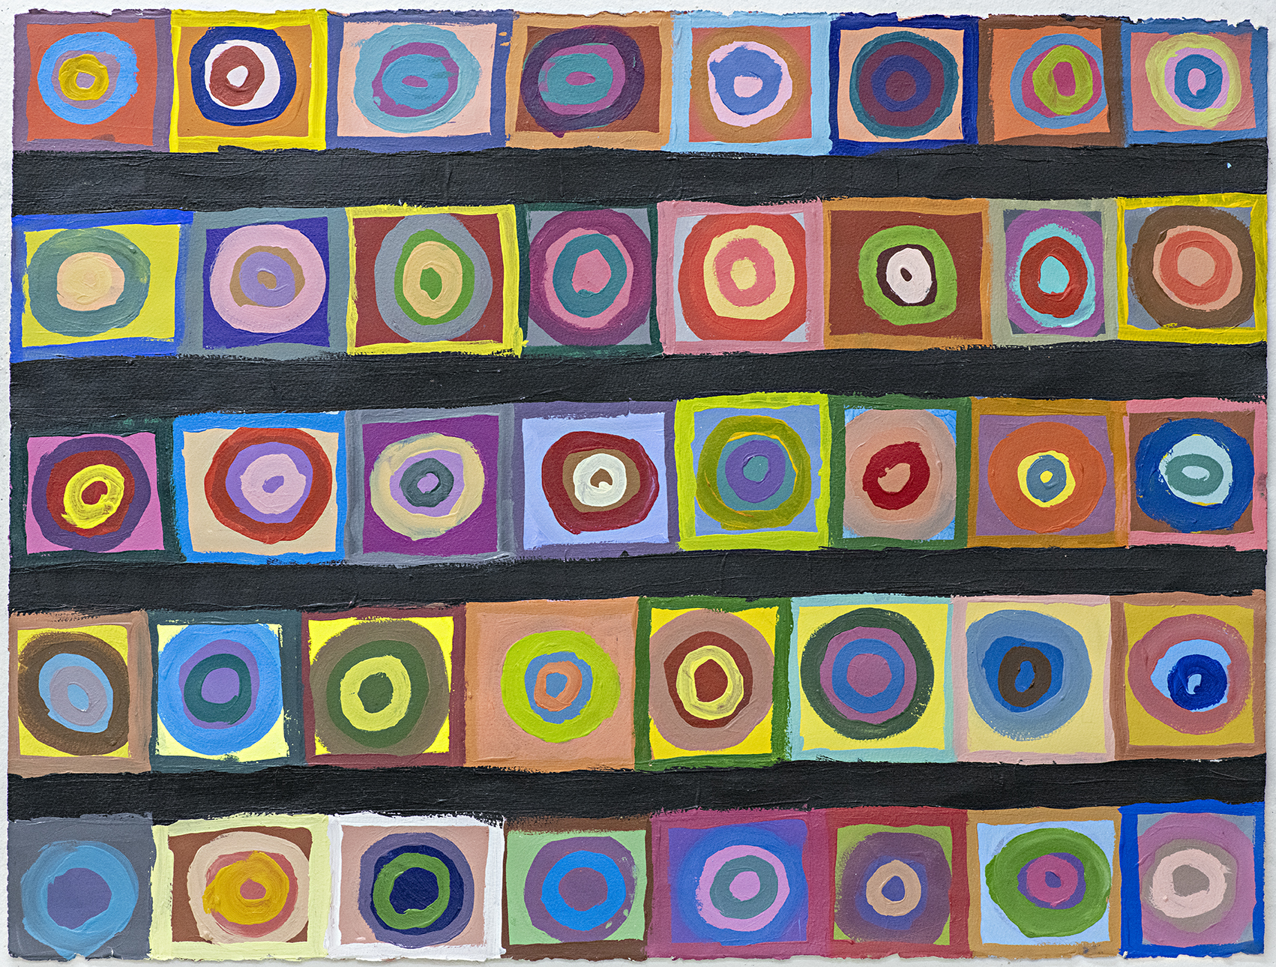
Audiences can expect a dynamic display of unique perspectives on the world; showcasing pop and street culture, political and social issues, as well as abstract imaginings explored by the artists.

Monica Lazzari is a regular APA artist known for complex abstract paintings and collage. Her work is vibrant and multi-layered by incorporating bright saturated colours, dot technique, abstract shapes and geometric patterns. Lazzari strikes a balance between impulsiveness and planned structure in her compositions. Other exhibitions she has participated in include Home, Now the heart is filled with gold as if it were a purse (by Glenn Barkley), and several Annual Gala exhibitions held at Arts Project Australia.

Rebecca Scibilia utilises a range of media sourcing imagery from popular culture items for her work. Using items such as DVD covers and celebrity magazines, Scibilia draws inspiration from her recent experience in Japan. An APA artist since 1999, she has had three solo exhibitions across Australia and Japan.

James MacSporran is an emerging artist who presented his first solo exhibition in 2020 and has been involved in group exhibitions across Australia, New York and Hong Kong. Specialising in painting and drawing on paper and canvas, MacSporran draws inspiration from trains and cityscapes, and embodies a blend of abstraction and graffiti through densely layered artworks.

Samraing Chea is also an emerging artist who has been with Arts Project for nine years and held his first solo in 2018 at Reading Room. Exhibiting across Australia and New York, Chea primarily uses greylead and colour pencil on paper. His work contains humorous and startling social commentary with a signature line of text at the bottom of each drawing that adds his inspiration or a witty thought leaving the viewer to interpret the scene.

A creative social enterprise providing support for individuals with intellectual disabilities, Arts Project Australia is a not-for-profit organisation promoting artists work and advocating for inclusion within contemporary art practice. Since its inception, Arts Project Australia has continued to strive for excellence, both in the quality of the exhibitions presented at the Collingwood Yards space, and the quality of the innovative studio program attended by 150+ artists at their Northcote location and online (Satellite Arts).

Arts Project Australia presents 4 x 4 Artist Solos
Exhibition dates: 15 May - 27 June 21
Opening: Saturday 15 May, 2-4pm
Location: Collingwood Yards, Level 1, Perry St entrance
https://www.artsproject.org.au/event/4-x-4-artist-solos-apa/

Supported by Leonard Joel, Calvert-Jones Foundation and Art Guide Australia

Image credit: Samraing Chea, A Semi-trailer Truck with a Tanker Acehieved the Small Town to the Gas Station, 2019, greylead pencil, pencil on paper, 17.5 x 25 cm, SACH20-0002. Courtesy of the artist and Arts Project Australia, Melbourne *spelling mistakes intentional

